**1.INTRODUCTION**

* Online Doctor System will provide you the power of direct interaction between doctors of your choice as and when required for your small problems.
* Online Doctor System allows doctors to register and provide details regarding their specialization, clinics or hospitals and timeslots.
* Using this web Online Doctor System, patients will able to fill online form in just few seconds before entering to the virtual office room.
* Patient can search various doctors by specialization, location and can take appointment by looking for available time slots at clinics or hospitals.
* Doctor accepts the appointment requests and manages timeslots.
* Patients will get all their reports and medicine prescriptions in their inbox by notification indication just after appointment session.
* Online Doctor System also provides information regarding various diseases their causes, symptoms, syndromes, remedies and medicines.
* There are 6 modules used in the system :
  + Patient Form and Login.
  + Online Appointment.
  + Medicine.
  + Referral.
  + Online Reports.

**MODULES**

1. Patient Form and Login.
2. Online Appointment.
3. Medicine.
4. Referral.
5. Payment.
6. Online Reports.

* **Patient Form and Login**

For the first time visitors, they have to just enter their basic details and can enter their dashboard. System will take care of creating their new profile. For existing patients, they will have to enter their id and password which are sent to their email earlier. This module will like virtual office from where all activity can be performed.

* **Online Appointment**

Through this module, patients can select doctors and have discussion regarding their health problems. Patients will able to get their availability time or choose from the available ones and start their diagnosis immediately.

* **Medicine**

This module will provide details of medicines which should be taken by the patients. It will also include the limit up to which these medicines should be taken and date to have meet again with doctors.

* **Referral**

Referral module will allow patients to change their doctors. For this process, patients have to click on the doctor name whose request will be made available to particular doctor inbox and provide their meeting time.

* **Online Report**

Patients can get their lab results and health reports through this section which is available under each patient homepage. When documents are available under this module, a special notification symbol appears above it which helps to notify their patients. Thus it provides relieve to patients for carrying these from here and there.

**2.FEASIBILITY STUDY**

Feasibility is the determination of whether or not a project is worth doing. The process followed in making this determination is called a Feasibility Study. Once it has been determined that the project is feasible keeping the benefit of the Organization in mind, the analyst can go ahead and prepare the project specification, which finalizes the project requirements. Different tests of feasibility are studied during the investigation. The main of them are –

* Technical feasibility
* Economical feasibility
* Operational feasibility

**2.1 Technical feasibility:**

This is concerned with specifying equipment and software that will successfully satisfy the user requirement. It involves determining whether or not a system can actually be constructed or upgraded to solve the problem at hand. The technical needs of a system may vary considerably, but might include the following:

* The necessary technology of both hardware and software existed and also could be acquired for the new system.
* As the improvement in storage technology has developed over the recent years, data storage is becoming easier and safer.
* The new system with powerful database technology has the capacity to hold the proposed data.

Technically, the system is designed in such a way that it provides accuracy, reliability, easy access, data security and integrity. Hence this project is technically feasible.

**2.2 Economical Feasibility**

Economical feasibility involves estimating benefits and costs. These benefits and costs may be tangible or intangible. It is seen whether the expenditure incurred for developing the new system will be cost effective or not. Because of the confusion between the types of costs, it is sometimes very difficult to decide if the benefits outweigh the costs. This basically involves top-level management of the company who are the decision makers. Some Key findings from the study are listed below.

* There was no extra cost burden to conduct a full systems investigation.
* Basic Hardware and Software would ensure the smooth run of the application, as the necessary tools were easily available.
* The benefits are in the form of reduced costs with merely any errors, thus reducing the manual work.
* If the system were used without any major changes to it, no extra costs would be incurred.

The cost of the overall functionalities is less than the usability. Hence this project is economically feasible.

**2.3 Operational Feasibility**

Operational feasibility deals with the human aspect of the organization. Proposed projects are beneficial only if they can be turned into information systems that will meet the organization’s operating requirements. This feasibility test asks whether the system will work when developed and installed. The users need to be convinced about the advantages of the new system.

Unless this is done effectively, the system would not be implemented even after its development and the old system would continue to be used. Some key findings from the study are as follows.

* It has been found to be well supportive by both the Management and the Users. If changes are needed, it has been notified and comprehensive solution has been designed.

Hence this project is operationally feasible.

**3. LITERATURE SURVEY**

**3.1 Existing System**

* Under manual System, you have to first wait in line to take appointment for the doctors and wait for your time to have meet with them and discuss on your health problems.
* As you have to provide your information and other reports many times at different places such as the medicine store which is again a burden of carrying documents.
* You have to be present physically at the doctor’s cabin. Patients have to visit on another day of after some hours to take their health reports which involves extra care person with patients anytime.
* Under manual system, the only accepted payment method is by cash and if patients due to some reasons are not having cash on time may face difficulties and not able to get treatment.

**DRAWBACKS**

* The redundancy of stored data
* Inconsistencies in the stored data
* Human error
* Slower updating of data and slower retrieval
* Clumsy and error prone
* Time consuming as every day entries have to be made in many books
* Limited information can be entered about the case. So for more information the owner has to look elsewhere

**3.2 Proposed System**

* To make a truly Online Doctor System to have meet with online doctors, all manual process has been automated through this system.
* Patients have to fill online form by which id and password created and sent to their email and upon accepting data, automatic login to patient panel.
* Through this panel, patients can select the doctors and have appointment with them on their time from their own place.
* Patients will get all their reports and medicine prescriptions in their inbox by notification indication just after appointment session.
* There is no need of cash and a secure payment gateway has been used to pay the required fees using their account or debit or credit card.

**DATA FLOW DIAGRAM**

**Level 0:**

Mantains System

Add Details

Get Patient Details

Add Details

Gets Madical Assistents

Doctor

Admin

Patients

**Level 1:**

Admin

Appointment Details

Payments

Reports

Doctor Details

Medicine Details

Patient Details

Doctor

Appointment Details

Payments

Reports

Doctor Details

Medicine Details

Patient Details

Patient

Appointment Details

Payments

Reports

Doctor Details

Medicine Details

Patient Details

**4.SYSTEM CONFIGURATION**

**4.1 HARDWARE REQUIREMENTS**

* **Processor :**Intel i3
* **Hard Disk :** 5GB
* **Main Memory :** 100MB
* **I/O Device :** Color monitor, Mouse, Keyboard.

**4.2 SOFTWARE REQUIREMENTS**

* **Operating System:** Windows7\Above.
* **Client Side :** HTML, CSS, JavaScript
* **Server Side :** JSP
* JDK [ Java Development Kit]
* **Back End :** My sql, Apache Tomcat
* **Browser :** All browsers are supported.

**5. ARCHITECTURE OF THE PROJECT**

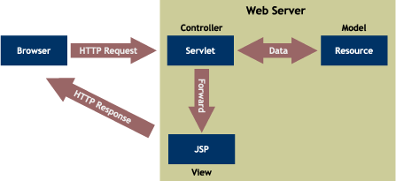

In the Design of our website we made an assumption that we are accessing the database of different city Dealers to get the Booking information. Any last minute changes to the taking appoint from doctors. Schedule are taken care by the admin. Presently we are accessing database. In our website we will be maintaining the table to hold user information, his appointment and report details.

The figure shows how our website is organized. The Servlet accesses the Database, which use the bean. The Servlet generates a DOM tree, which contains the required information. This HTML it transformed in to a code containing, JAVASCRIPT code. This is displayed to the user in a web browser. In case of a PDA device WML code is generated by the Web Application.

**5.1 CONTROL FLOW IN A TYPICAL USER SESSION:-**

* + - 1. Users will type the URL of our site : http://localhost:8080/doctor/home.html in the

browser.

* + - 1. Users will be shown our homepage containing various page links and search option.
      2. The patient is directed to the home page where he can start his search for his required doctor.
      3. Patient can select the doctor/department for taking appointment.
      4. Patient can also view the particular doctor, department, timeslot.
      5. Doctor can also view his appointments and upload reports of particular patient.
      6. Administrator will click on the Login button to log on into our admin account.
      7. The user-id and password are validated and the administrator is allowed to login.
      8. The administrator can view the insert, delete, view ,update by click on the Search button.
      9. Administrator will maintain all information of doctor and patient.

**6. TECHNOLOGY USED IN PROJECT**

**6.1 INTRODUCTION TO HTML**

HTML (Hypertext Markup Language) is used to create document which capability of World Wide Web. It is simply a collection of certain keywords called ‘Tags’ that are helpful in writing the document to be displayed using a browser on internet.

It is a platform independent language that can be used on any platform such as windows, Linux, Macintosh and so on. To display a document in web it is essential to mark-up the different elements (headings, paragraphs, tables and so on) of the document with the HTML tags. To view a mark-up document, user has to open the document in the browser. A browser understands and interprets the HTML tags, identifies the structure of the document and makes decision about presentation (how the parts look) of the document

HTML also provides tags to make the document look attractive using graphics, font size and colors. User can make a link to the other document or the different section of the same document by creating Hypertext links also known as Hyperlinks.

**HTML TAGS**

|  |  |  |  |
| --- | --- | --- | --- |
| **Tag** | **Name** | **Code Example** | **Browser View** |
| <!-- | **Comment** | **<!--**This can be viewed in the **HTML** part of a document**-->** | Nothing will show [(Tip)](javascript:void(0);) |
| <a - | **Anchor** | **<a href=**"http://www.domain.com/"> Visit Our Site**</a>** | Visit Our Site [(Tip)](javascript:void(0);) |
| <b> | **Bold** | **<b>**Example**</b>** | **Example** |
| <big> | **big (text)** | **<big>**Example**</big>** | Example [(Tip)](javascript:void(0);) |
| <body> | **body of HTML document** | **<body>**The content of your **HTML** page**</body>** | Contents of your web page [(Tip)](javascript:void(0);) |
| <br> | **line break** | The contents of your page**<br>**The contents of your page | The contents of your web page The contents of your web page |
| <center> | **Center** | **<center>**This will center your contents**</center>** | This will center your contents |
| <dd> | **definition description** | <dl> <dt>Definition Term</dt> **<dd>Definition of the term</dd>** <dt>Definition Term</dt> **<dd>Definition of the term</dd>** </dl> | Definition Term  **Definition of the term**  Definition Term  **Definition of the term** |
| <dl> | **definition list** | **<dl>** <dt>Definition Term</dt> <dd>Definition of the term</dd> <dt>Definition Term</dt> <dd>Definition of the term</dd> **</dl>** | Definition Term  Definition of the term  Definition Term  Definition of the term |
| <dt> | **definition term** | <dl> **<dt>Definition Term</dt>** <dd>Definition of the term</dd> **<dt>Definition Term</dt>** <dd>Definition of the term</dd> </dl> | **Definition Term**  Definition of the term  **Definition Term**  Definition of the term |
| <em> | **Emphasis** | This is an **<em>**Example**</em>** of using the emphasis tag | This is an *Example* of using the emphasis tag |
| <embed> | **embed object** | **<embed** src="yourfile.mid" width="100%" height="60" align="center"> | [(Tip)](javascript:void(0);) |
|  |  |  |  |

|  |  |  |  |
| --- | --- | --- | --- |
| <font> | **font** | **<font** face="Times New Roman">Example**</font>** | Example [(Tip)](javascript:void(0);) |
| <font> | **font** | **<font** face="Times New Roman" size="4">Example**</font>** | Example [(Tip)](javascript:void(0);) |
| <font> | **font** | **<font** face="Times New Roman" size="+3" color="#ff0000">Example**</font>** | Example [(Tip)](javascript:void(0);) |
| <form> | **form** | **<form** action="mailto:you@yourdomain.com"> Name: <input name="Name" value="" size="10"><br>  Email: <input name="Email" value="" size="10"><br> <center><input type="submit"></center> **</form>** | Top of Form  Name: [(Tip)](javascript:void(0);)  Email:  Bottom of Form |
| <h1> <h2> <h3> <h4> <h5> <h6> | **heading 1** **heading 2** **heading 3** **heading 4** **heading 5** **heading 6** | **<h1>**Heading 1 Example**</h1>** **<h2>**Heading 2 Example**</h2>** **<h3>**Heading 3 Example**</h3>** **<h4>**Heading 4 Example**</h4>** **<h5>**Heading 5 Example**</h5>** **<h6>**Heading 6 Example**</h6>** | **Description: http://www.web-source.net/graphics/headings.gif** |
| <head> | **heading of HTML document** | **<head>**Contains elements describing the document**</head>** | Nothing will show |
| <hr> | **horizontal rule** | **<hr />** | Contents of your web page [(Tip)](javascript:void(0);)  Contents of your web page |
| <hr> | **horizontal rule** | **<hr** width="50%" size="3" /> | Contents of your web page  Contents of your web page |
| <hr> | **horizontal rule** | **<hr** width="50%" size="3" noshade /> | Contents of your web page  Contents of your web page |
| <hr> (Internet  Explorer) | **horizontal rule** | **<hr** width="75%" color="[#ff0000](http://www.web-source.net/216_color_chart.htm.htm)" size="4" /> | Contents of your web page  Contents of your web page |
| <hr> (Internet  Explorer) | **horizontal rule** | **<hr** width="25%" color="[#6699ff](http://www.web-source.net/216_color_chart.htm)" size="6" /> | Contents of your web page  Contents of your web page |

**6.2 Introduction to JSP** (**Java Server Pages**)

Java Server Pages (JSP) is a technology based on the Java language and enables the development of dynamic web sites. JSP was developed by Sun Microsystems to allow server side development. JSP files are HTML files with special Tags containing Java source code that provide the dynamic content.

**What is JavaScript?**

* JavaScript was designed to add interactivity to HTML pages
* JavaScript is a scripting language
* JavaScript is usually embedded directly into HTML pages
* JavaScript is an interpreted language (means that scripts execute without preliminary compilation)
* Everyone can use JavaScript without purchasing a license

**Why we use JSP?**

JSP is easy to learn and allows developers to quickly produce web sites and applications in an open and standard way. JSP is based on Java,an object-oriented language. JSP offers a robust platform for web development.

**Main reasons to use JSP:**

* Multi platform
* Component reuse by using Javabeans and EJB.
* Advantages of Java.
* You can take one JSP file and move it to another platform,web server or JSP Servlet engine.

**6.3 JavaScript**

* JavaScript was basically used for client-side validation.
* JavaScript is compatible with all versions of Microsoft Internet Explorer and Netscape Navigator.
* We have small java scripts, which are lightweight and will not hinder the download time of the HTML document significantly.

**6.4 ABOUT TO MYSQL**

MYSQL provides data storage for the data what we entered in the JAVA this acts as media for storing data. A database is a collection of data with a given structure for accepting, storing and providing on demand, data for one or multiple uses.

In database environment common data are available and are used by several users. Instead of each program managing its own data, data across applications are shared by authorized users with the database software managing the data as an entity. A program now requests data through the data base management system (DBMS), which determines data sharing.

**Objectives of Database are**

**Controlled redundancy:** the redundant data occupies space and therefore, is wasteful. A unique aspect of database design is storing data only once, which controls redundancy and improves system performance.

**Accuracy and Integrity:** the accuracy of a database ensures that data quality and content remains constant. Integrity controls, detect data inaccuracies where they occur. Performance this objective emphasizes response time to inquiries suitable to the users of the data. How satisfactory the response time is depends on the nature of the user- database dialogue.

**6.5 APACHE TOMCAT SERVER**

**Apache Tomcat** is a servlet container developed by the Apache Software Foundation (**ASF).** Tomcat implements the Java Servlet and the Java Server Pages (JSP) specifications from Sun Microsystems, and provides a "pure Java" HTTP web server environment for Java code to run.

Tomcat should not be confused with the Apache web server, which is a C implementation of an HTTP web server; these two web servers are not bundled together. Apache Tomcat includes tools for configuration and management, but can also be configured by editing XML configuration files.

Apache software is built in a community process, with both user and developer [mailing lists](http://tomcat.apache.org/lists.html). The developer list is where discussion on building and testing the next release takes place, while the user list is where users can discuss their problems with the developers and other users.

A number of free Apache Tomcat resources and communities have developed in 2010 including [Tomcatexpert.com](http://www.tomcatexpert.com/), a [Spring Source](http://en.wikipedia.org/wiki/SpringSource) sponsored community for developers and operators who are running Apache Tomcat in large-scale production environments, and MuleSoft's [Apache Tomcat Resource Center](http://www.mulesoft.com/understanding-apache-tomcat/), where you can find instructional guides on installing, updating, configuring, monitoring, troubleshooting and securing various versions of Tomcat.

Tomcat is enterprise class, robust web server which comes bundled with Java Servlets and JSP that provides a java application server environment

One of the other major issues why we chose Tomcat was Scalability. Presently Java

is our core technology used for portability and in future if we want to make our site be reachable to users using Microsoft products we would be having no conflicts between the servers because Tomcat can be deployed as either a standalone product with its own internal Web server or in conjunction with several other Web servers, including

* Netscape Enterprise Server.
* Microsoft Internet Information Server.
* Microsoft Personal Web Server.

It adheres to the latest standards, which expands the security features.  
Configuration, tuning and maintenance are lot easier than compared to other prevailing web servers.

Since we were not going for enterprise java beans in our project we didn’t feel the necessity of going for other application servers like J2EE or JBOSS .We were basically looking for a reliable web server which would be compatible with both the front-end and back-end technologies we were using and our ultimate choice was Apache’s Tomcat Web Server.

|  |  |
| --- | --- |
| **[Apache Tomcat Logo](http://en.wikipedia.org/wiki/File:Tomcat-logo.svg)** | |
|  | |
| **Screenshot**[[show]](javascript:toggleNavigationBar(1);) | |
| [**Developer(s)**](http://en.wikipedia.org/wiki/Software_developer) | [Apache Software Foundation](http://en.wikipedia.org/wiki/Apache_Software_Foundation) |
| [**Stable release**](http://en.wikipedia.org/wiki/Software_release_life_cycle) | 7.0.22[[1]](http://en.wikipedia.org/wiki/Apache_Tomcat#cite_note-0) / October 1, 2011; 40 days ago |
| **Development status** | Active |
| [**Written in**](http://en.wikipedia.org/wiki/Programming_language) | [Java](http://en.wikipedia.org/wiki/Java_(programming_language)) |
| [**Operating system**](http://en.wikipedia.org/wiki/Operating_system) | [Cross-platform](http://en.wikipedia.org/wiki/Cross-platform) |
| [**Type**](http://en.wikipedia.org/wiki/List_of_software_categories) | [Servlet container](http://en.wikipedia.org/wiki/Java_Servlet#Servlet_containers) [HTTP](http://en.wikipedia.org/wiki/Hypertext_Transfer_Protocol) [web server](http://en.wikipedia.org/wiki/Web_server) |
| [**License**](http://en.wikipedia.org/wiki/Software_license) | [Apache License](http://en.wikipedia.org/wiki/Apache_License) 2.0 |
| **Website** | [http://tomcat.apache.org](http://tomcat.apache.org/) |

**7. DETAIL DESIGN**

Detailed design covers the study of the major entities involved in the system, their attributes and relationships, how they can be transformed into normalized tables and what is the dependency among the tables. While system definition is design oriented, detailed design is implementation oriented. By defining logical and physical structure of the database, detailed design guides the implementation phase.

**7.1 Table Design**

**7.1 Register table**

|  |  |  |  |
| --- | --- | --- | --- |
| **Column name** | **Data type** | **Null** | **Key** |
| Uid | int |  | Primary key |
| First name | varchar |  |  |
| Last name | varchar |  |  |
| Username | varchar |  |  |
| Password | varchar |  |  |
| Mobile no | int |  |  |
| Address | varchar |  |  |

**7.2 Appointment table**

|  |  |  |  |
| --- | --- | --- | --- |
| **Column name** | **Datatype** | **Null** | **Key** |
| Appointment id | int |  | Primary key |
| Speciality | varchar |  |  |
| Doctor | varchar |  |  |
| Adate | date |  |  |
| Atime | time |  |  |
| Name | varchar |  |  |
| Phone no | int |  |  |
| email | varchar |  |  |

**8. SNAPSHOTS**

**Home**

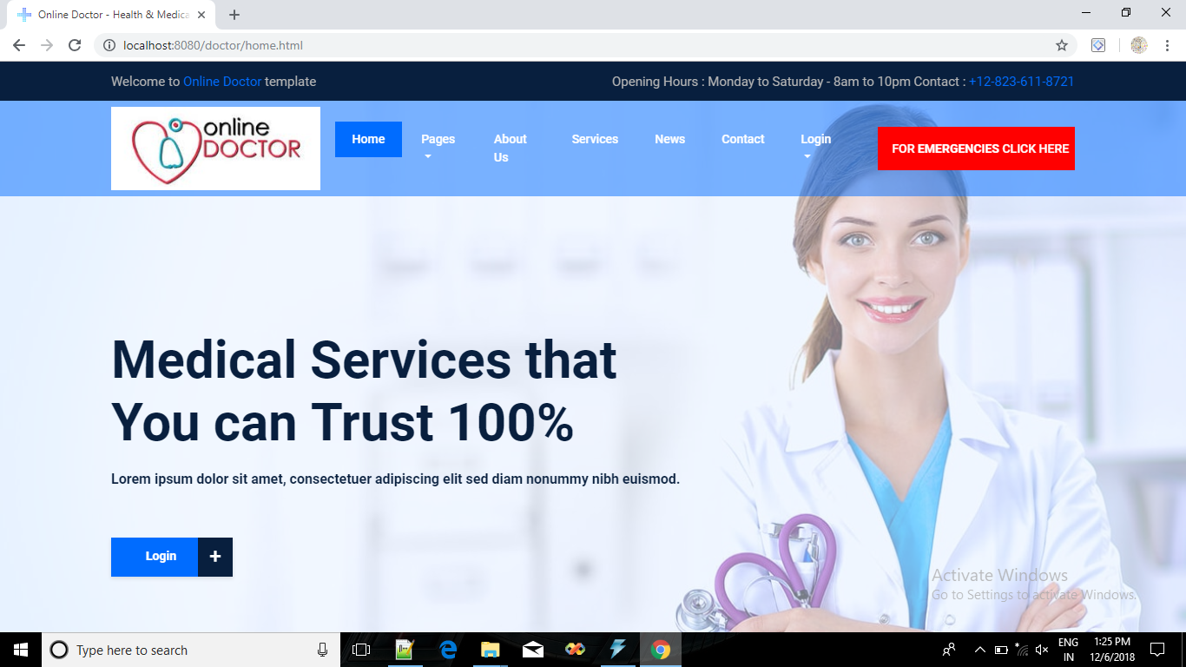

**Login**

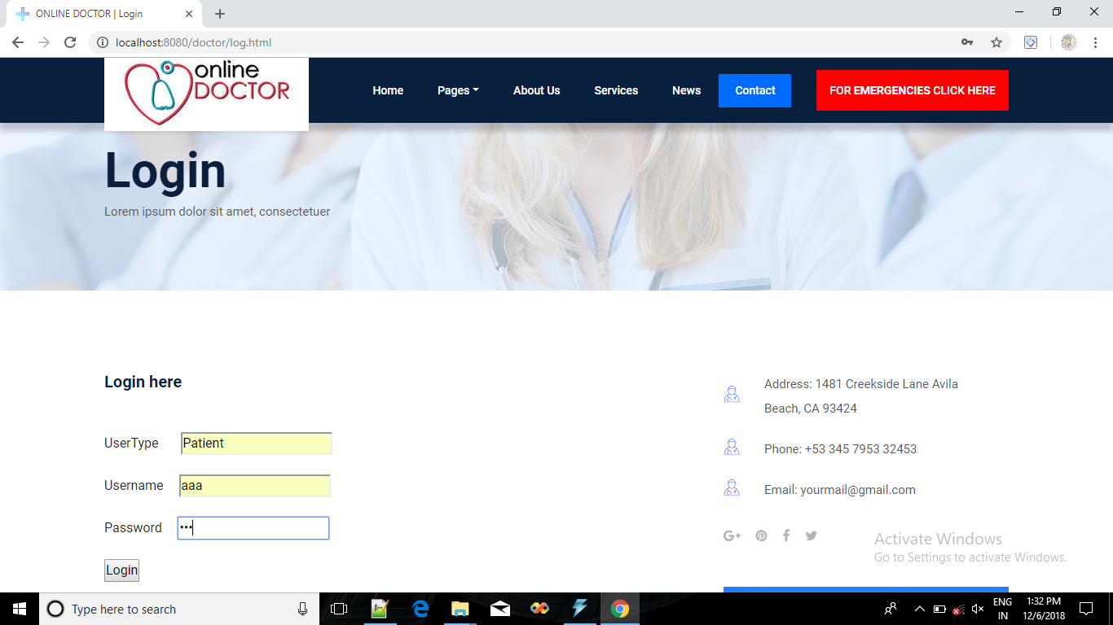

**Make Appointment**

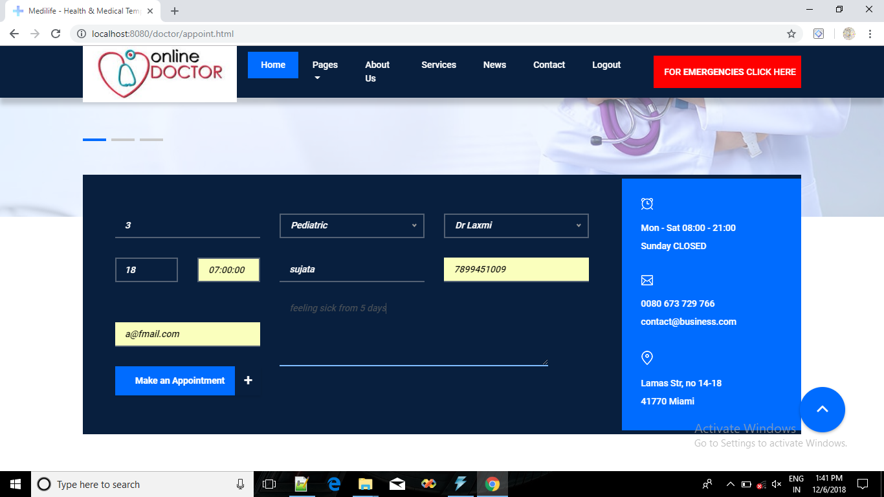

**Change Appointment**

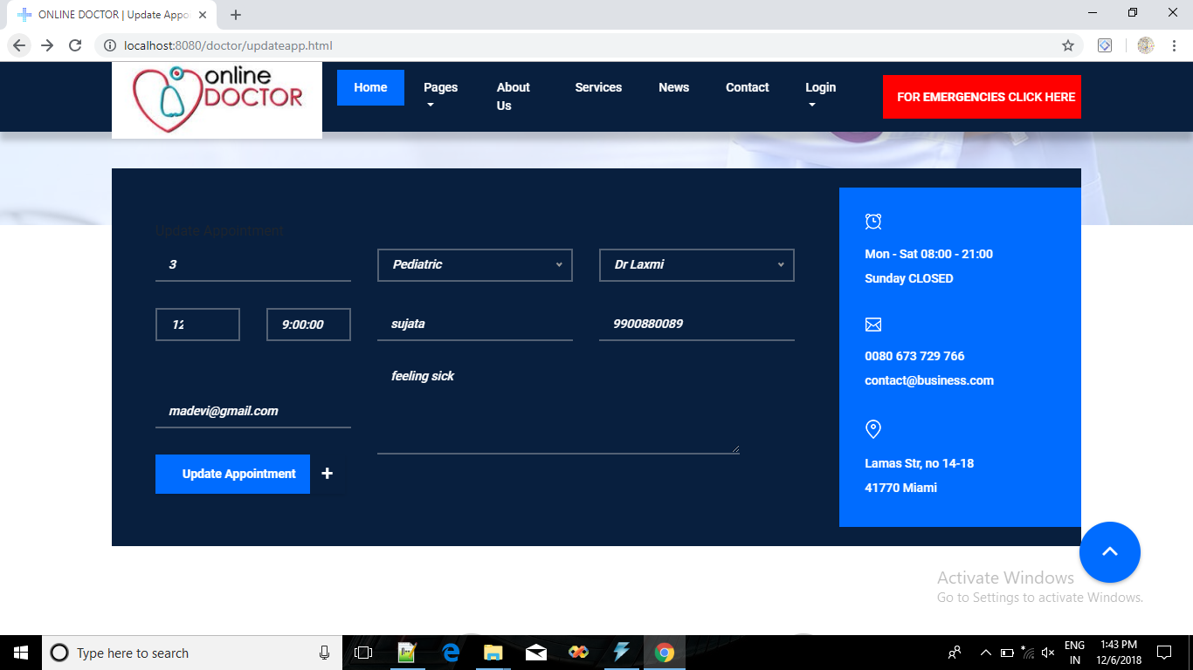

**9. CONCLUSION**

Using Online Doctor System applications, patients will able to fill online form in just few seconds before entering to the virtual office room. Patient can search various doctors by specialization, location and can take appointment by looking for available time slots at clinics or hospitals. Doctor accepts the appointment requests and manages timeslots. Patients will get all their reports and medicine prescriptions in their inbox by notification indication just after appointment session. Online Doctor System also provides information regarding various diseases their causes, symptoms, syndromes, remedies and medicines.

**10. FUTURE ENHANCEMENT**

Future enhancements are given below,

* Our project can implement in new version of JDK Package.
* This can be implementing in Mobile technology. Through Mobile also user can take appointments of doctor.
* As of now, the questions are directly asked to doctors, in future queries written into tables, site, problems can be solved by the administrator. Creating a computerized module for it.
* In future it can also modified or make some changes or more user friendly and more easy to access or maintained.
* This project can also implement in more other languages. For platform independent.
* Patient can get E–Mail from doctor about reports.

**11.BIBLIOGRAPHY**

* Programming with JAVA

-By Balaguruswamy.

* Java Complete Reference

-By Herbert Schildt.

* [www.Google.com](http://www.Google.com)
* [www.w3schools.com](http://www.w3schools.com)